# 1.下载jdk并安装，配置环境变量

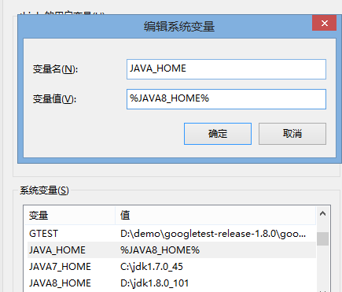

# 2.下载maven

<http://maven.apache.org/download.cgi> 下载 [apache-maven-3.3.1-bin.zip](http://apache.dataguru.cn/maven/maven-3/3.3.1/binaries/apache-maven-3.3.1-bin.zip) 解压

建立maven环境变量

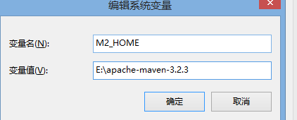

把%M2_HOME%\bin;配置到path变量中

创建路径 如：D:\m2\repository

# 3. apache-maven-3.2.3\conf 下的文件 settings.xml

<localRepository>D:/m2/repository</localRepository>

<mirror>

<id>aliyun</id>

<name>aliyun Maven</name>

<mirrorOf>*</mirrorOf>

<url>http://maven.aliyun.com/nexus/content/groups/public/</url>

</mirror>

</mirrors>

# 4 Eclipse中Maven的配置

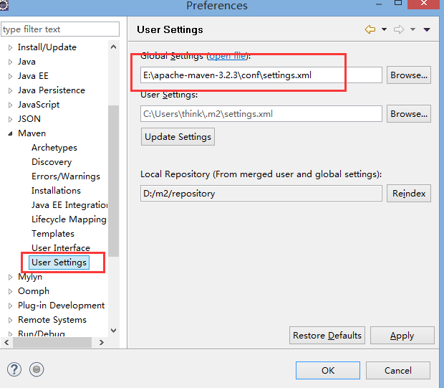

# 5.Eclipse新建Maven项目

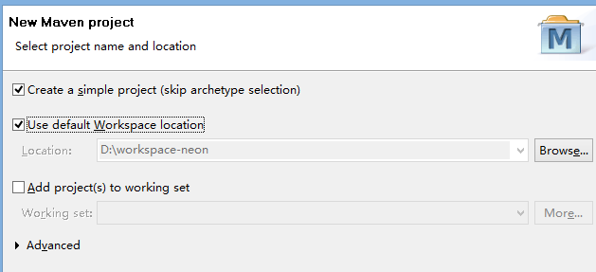

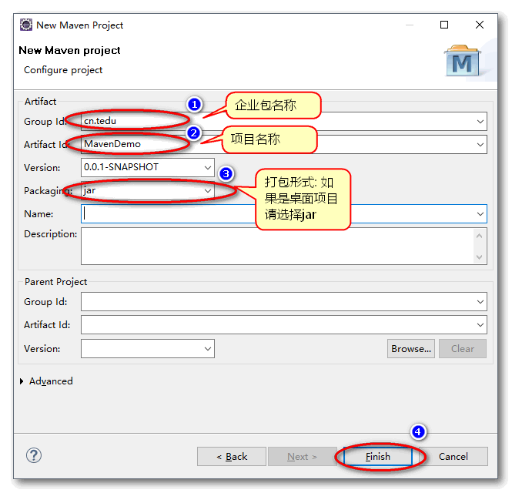

# 6.编辑 pom.xml

<dependency>

<groupId>org.apache.jmeter</groupId>

<artifactId>ApacheJMeter_core</artifactId>

<version>4.0</version>

</dependency>

<dependency>

<groupId>org.apache.jmeter</groupId>

<artifactId>ApacheJMeter_java</artifactId>

<version>4.0</version>

</dependency>